Standard Tasting Fee: $10+ tax Glass Bottle Wine Club
Thalia, 2018 $7 $24 $19.20 This white wine is a combination of the classic Rhône grapes of Marsanne and Roussanne which makes for a rich and deep wine made in small labor-intensive lots. It was aged in French oak barrels with full malolactic conversion which gives the body a full and roundness to it. It is a light yet complex wine that will enhance the flavors of seafood, chicken, duck, and cream-based pasta sauces. ABV 13.4%

Rosé, 2018 $7 $20 $16
Our 2018 Rosé is made from Cabernet Sauvignon, Cabernet Franc and Petit Verdot grapes traditionally used in Bordeaux that are harvested early and fermented like a white wine in temperature-controlled stainless steel tanks. To preserve a refreshing taste and texture, it is 50% whole-cluster pressed, 50% crushed with a 24 hour soak on the skins. ABV 11.6%

Petit Verdot, 2016 $8 $32 $25.60
Made exclusively of Petit Verdot grapes, this wine has strong cherry notes and was aged in the French oak barrels. An uncomplicated, robust varietal that pairs well with hearty red meat stews, and similar straightforward, rustic foods. ABV 13.9%

Clio, 2015 $10 $35 $28
It is a Bordeaux style wine in a classic blend of 30% each of Cabernet Sauvignon, Cabernet Franc and Petit
Verdot, and 5% each of Merlot and Malbec. This wine is aged for three years in 30% new, 50% once-filled and 20% neutral French oak barrels. This wine has a pronounced Medoc quality that complements a wide range of cuisine (as a good Bordeaux should). ABV 13.5%.

Cabernet Franc, 2015 $8 $32 $25.60
Aged 40 months in used French oak barrels, this wine is 75% Cabernet Franc and 25% Petit Verdot. This wine has an elegant lift reminiscent of Loire Cabernet Francs. Refreshing to the end of the bottle, it’s a wine that maintains a synergistic energy throughout the food course it is allied with. This is a fresh bright wine that pairs well with steak dinners and red sauced pastas. ABV 14.1%.

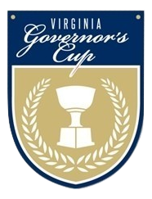
Multi-bottle Discounts: 10% off 3 bottles, 15% off 6, and 20% off a case.
Wine Club members save 20% all the time. Not a Muse Wine Club Member? Ask to Join Now and Save! We ship to 36 states.
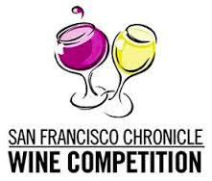
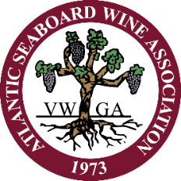
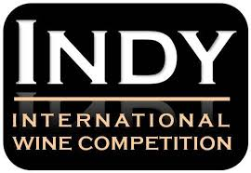
Gold
Thalia ’15, Calliope ’17, Urania ‘17
Best in Show
Calliope ‘17

Governor’s Cup
Clio ‘09
Gold
Thalia ‘16

Tha
Double Gold
Clio ‘13

Gold
Clio ‘10, Clio ‘13

Gold
Thalia ‘15, Cab Sauv ‘15

For Sale by Bottle Bottle Wine Club
Calliope, 2017 $32 $25.60
This wine is a Rhône blend of 65% Grenache and 35% Mourvèdre, aged in the French oak barrels. It possesses the characteristics of a traditional Châteauneuf-du-Pape. ABV 15%

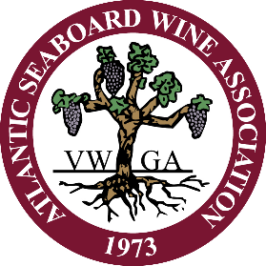
Multi-bottle Discounts: 10% off 3 bottles, 15% off 6, and 20% off a case.
Wine Club members save 20% all the time. Not a Muse Wine Club Member? Ask to Join Now and Save! We ship to 36 states.
Gold
Thalia ’15, Calliope ’17, Urania ‘17
Best in Show
Calliope ‘17

Gold
Thalia ‘15, Cab Sauv ‘15

Gold
Clio ‘10, Clio ‘13

Double Gold
Clio ‘13

Governor’s Cup
Clio ‘09
Gold
Thalia ‘16

Tha

